***PAAREES PERFUMES***

***DAVID OFF***

***FOR WOMEN***

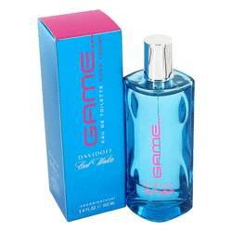

***Cool Water Game***

***Description:***

Cool Water Game by Davidoff Perfume. Boost your confidence, and lift your mood by applying Cool Water Game for women, made by Davidoff in 2006. Smell is the most powerful sense, and this fragrance combines apple, lemon, water lily, freesia and exotic fruits notes to create a sweet, flowery scent with a hint of citrus that quickly captures attention. Whether you're giving a presentation at work or going out for a romantic dinner, apply this fragrance to ensure you smell and feel your best.